CONTROL STRATEGY OF SWITCHING REGULATORS FOR FUEL-CELL POWER APPLICATIONS
ABSTRACT
Cascaded multilevel converter (CMC)-based energy storage system, which consists of cascaded H-bridge converters and energy storage components, is a promising option to compensate fluctuating electric power of renewable energy. This paper proposes a novel single-phase CMC-based battery storage system, which includes an LC branch. The cascaded converter cells and the LC branch form an auxiliary power loop, which could realize active power exchange between different cells with the proposed dual-frequency phase-shifted carrier pulse width modulation (DFPSC PWM). The principle and effectiveness of DF-PSC PWM and the power transfer mechanism are analyzed. Meanwhile, the design of the tuned filter, output filter, and the state of charge balancing control system is introduced. The operation principle of the power exchange in the proposed energy storage system has been successfully verified by simulation and experimental results.

BLOCK DIAGRAM FOR PROPOSED SYSTEM
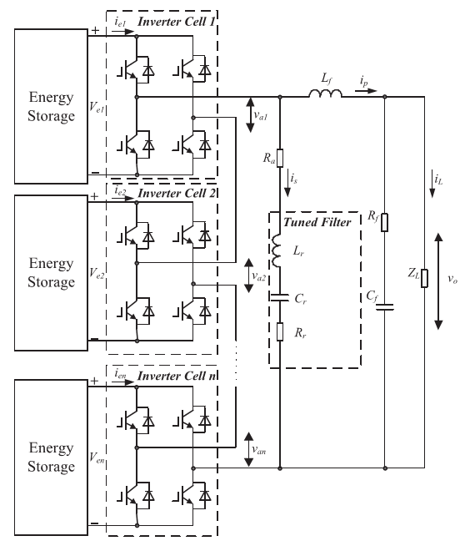
Fig. 1. Topology of proposed CMC with auxiliary power loop.
DESIGNG SOFTWARE AND TOOLS:
MAT LAB /SIMULATION Software and simu power systems tools are used. Mainly control system tools, power electronics and electrical elements tools are used.

